X1 + X2 + 3X4 = 4

2X1 + X2 – X3 + X4 = 1

3X1 – X2 – X3 + 3X4 = -3

-X1 + 2X2 + 3X3 -X4 = 4

* Langkah 1: Ubah ke bentuk a.x = H

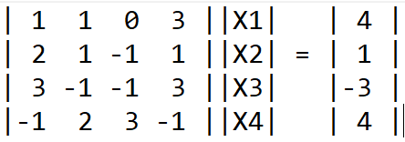

* Langkah 2: Tentukan nilai-nilai elemen matriks L dan matriks U
  + Pada j = 1 diperoleh: *l*11 = *a*11 = 1

*l*21 = *a*21 = 2

*l*31 = *a*31 = 3

*l*41 = *a*41 = -1

* + Pada i = 1 diperoleh: *u*11 = *a*11 / *l*11 = 1

*u*12 = *a*12 / *l*11 = 1

*u*13 = *a*13 / *l*11 = 0

*u*14 = *a*14 / *l*11 = 3

* + *l*22 = *a*22 - . *u*kj = *a*22 – *l21*\**u*12 = 1 – 2\*1 = -1
  + *l*32 = *a*32 - . *u*kj = *a*32 – *l31*\**u*12 = -1 – 3\*1 = -4
  + *l*42 = *a*42 - . *u*kj = *a*42 – *l41*\**u*12 = 2 – (-1)\*1 = 1
  + *u*23 = = = = 1
  + *u*24 = = = = 5
  + *l*33 = *a*33 - . *u*kj = *a*33 – (*l31*\**u*13 + *l32*\**u*23) = -1 – (3\*0 + -4\*1) = 3
  + *l*43 = *a*43 - . *u*kj = *a*43 – (*l41*\**u*13 + *l42*\**u*23) = 3 – (-1\*0 + 1\*1) = 2
* Langkah 3: Menyusun augmented matriks UH’